Fixed BPMN diagrams and IODs

BPMNs:
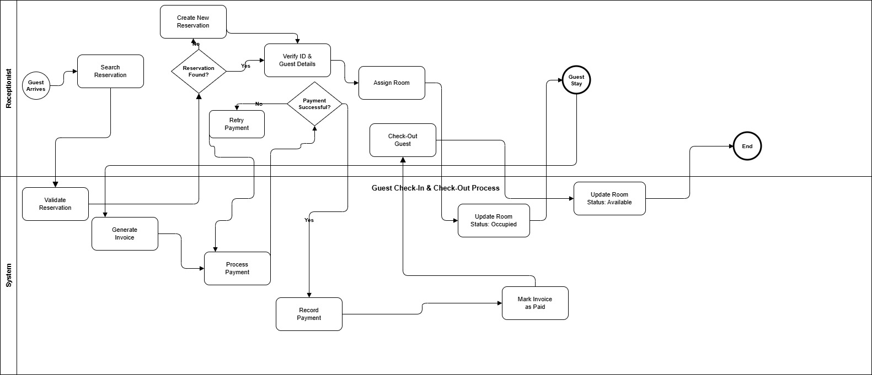
Reservation & Cancellation with Refund Process
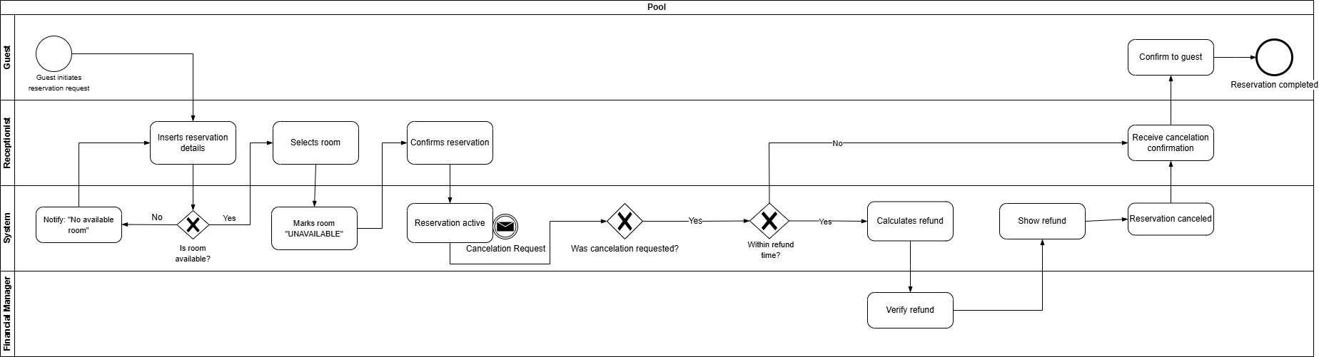
Room Cleaning & Maintenance Process
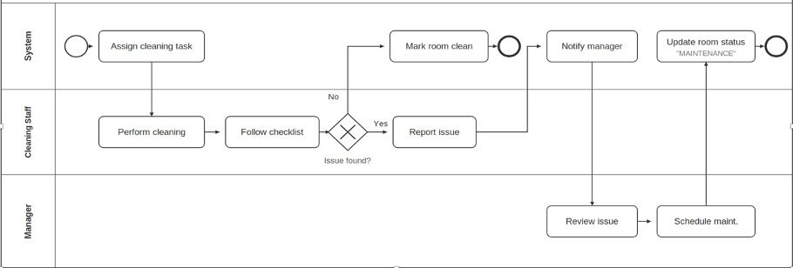
IODs:
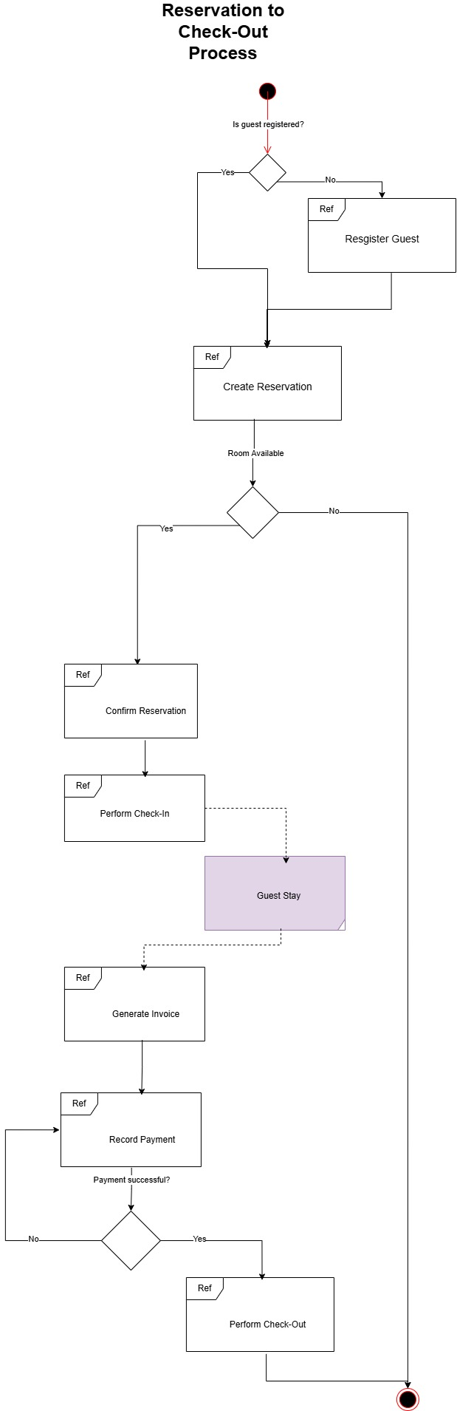

Cancellation & Refund Process
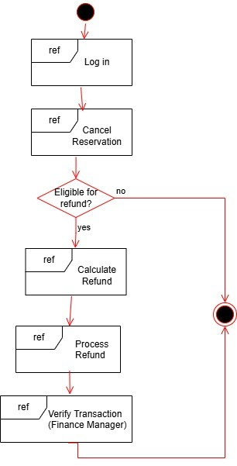

Cleaning & Maintenance Process
